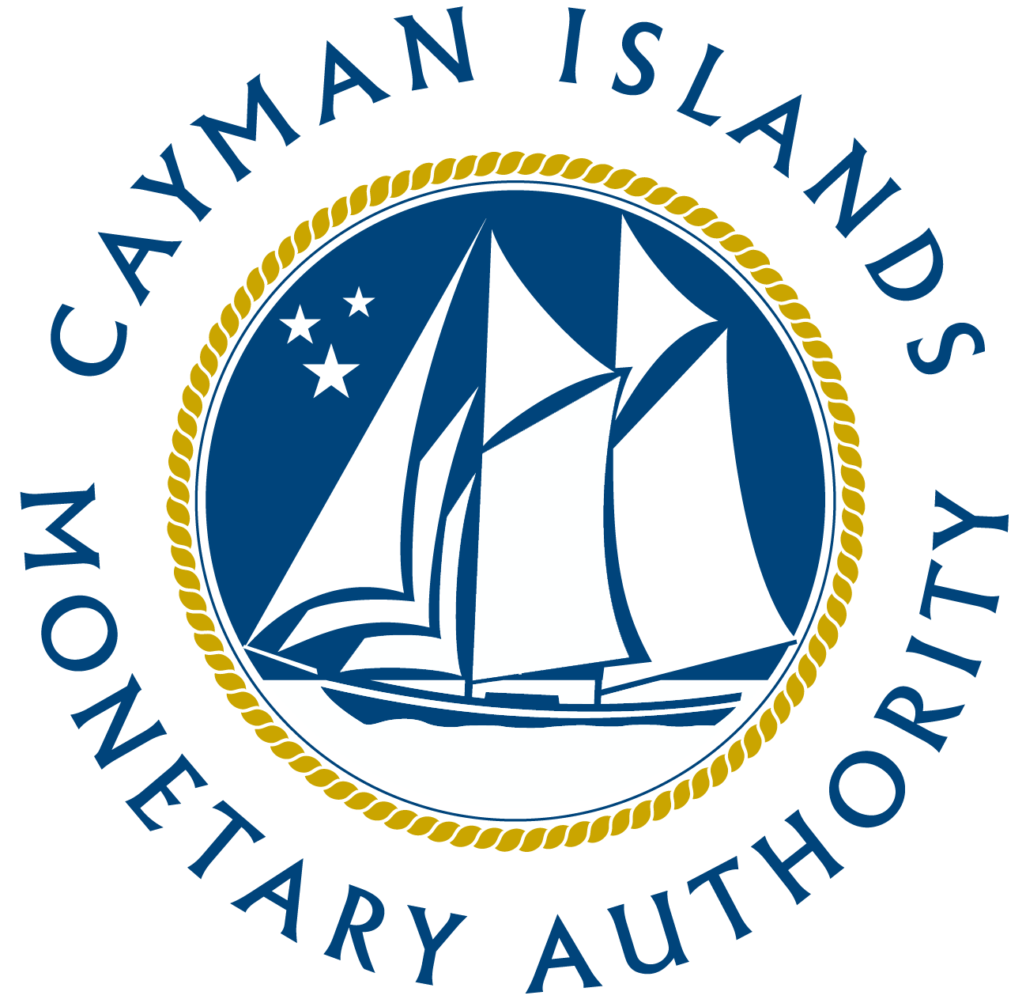
Securities Investment Business Licensees (“SIB Licensees”) Sector Assessment – December 2019

- INTRODUCTION

- The Cayman Islands was assessed by the Caribbean Financial Action Task Force (CFATF) against Financial Action Task Force (FATF) anti-money laundering and combating the financing of terrorism (AML/CFT) international standards in 2017. The assessment found that the Cayman Islands’ licensing and supervisory framework needed to be updated and further expanded to cover the analysis of ML/TF risks and vulnerabilities faced in the various financial sectors under the supervision of the Cayman Islands Monetary Authority (CIMA).

- This report provides a ML/TF risk assessment of the SIB Licensees and utilizes data collected as part of the AML/CFT surveys submitted by the SIB Licensees in relation to customer/customer type and their jurisdiction of domicile, distribution channels, products and services, jurisdictions operated in, and the effectiveness of actual and potential risk controls that are or can be put in place. The assessment of this data is considered integral to enhancing the risk-based approach commensurate with the size, nature and complexity of the SIB Licensees.

- Other data sources utilized, based on particular parameters from each document, include:

The National Risk Assessment;

International guidance documents such as FATF Guidance for the Securities Sector, FATF High and Other Monitored Jurisdictions, the United Nations Security Council and the Basel AML Index;

Supervisory judgment and expertise by CIMA staff; and
- Various guidance documents issued by CIMA.

- SIB Licensees are authorized by CIMA and include persons engaged in market making, dealing in securities, arranging deals in securities, advising on securities and managing securities.

- Securities investment business, as defined under schedule 1 of the SIBL, includes:
- shares and stock of any kind in the share capital of a company;
- debentures, debenture stock, loan stock, bonds, certificates of deposit and any other instruments that create or acknowledge debt (excluding various banking and monetary instruments e.g. cheques, mortgage instruments and land charges);
- warrants and other instruments which confer contractual or property rights;
- options on any security and on any currency, precious metal or an option on an option;
- futures; and
- rights under contracts for differences (e.g. cash-settled derivatives such as interest rate and stock index futures, forward rate agreements and swaps).

- The SIB Licensees Sectoral Risk Assessment is not intended to cover risks that may be specific to the circumstances of individual SIB Licensees but evaluates risks from a sectoral perspective.

- METHODOLOGY

- The SIB Licensees Sectoral Risk Assessment is predominantly based on CIMA having conducted a comprehensive data collection exercise from 83% of SIB Licensees during 2019, to cover the period from 1 July 2018 to 30 June 2019, in order to gather data on customers, products/services, geographic exposure and delivery channels to assess the risk in these five categories, resulting in a comprehensive representation of the sector.

- The sector was assessed against these factors that increase or decrease ML/TF risks, as follows:

Risk factor | Higher Risk | Lower Risk
The nature, size and complexity of the sector | · High value of assets under management coupled with high volumes of transactions executed.  · Volume of international transactions.  · Number of customers.  · No physical presence.  · Parent company, affiliate or subsidiary in higher risk jurisdictions.  · Principal place of business in higher risk jurisdictions. | · Low value of transactions.  · Low volume of transactions.  · Low assets under management.  · No assets under management.  · No customers (i.e. have not commenced business yet or in the final stages of winding down/cancelling the securities investment business licence).
Customer types | · Trusts.  · High net worth persons with KYD$4 million total assets.  · Sophisticated persons.  · Politically Exposed Person.  · Non-profit organizations.  · Corporates/financial institutions in higher risk jurisdictions.  · Individuals in higher risk jurisdictions.  · Nominees.  · Special purpose vehicles. | · Governments/public sector not from high-risk jurisdictions.  · Financial institutions not from high-risk jurisdictions.  · Non-financial institutions not from high-risk jurisdictions.
Transactions, products and services | · High complexity, high liquid and/or volatile products such as shares, options, futures, contracts for differences.  · Broker-dealers  · Maker makers  · Securities managers  · Forms of payment such as the acceptance of physical cash, travelers’ cheques, bearer shares, prepaid cards, virtual currencies or third party payments. | · Low complexity securities such as instruments creating or acknowledging indebtedness, instruments giving entitlements to securities and certificates representing certain securities.  · Advisory services solely.  · Arranger services solely.
Distribution/delivery channel | · Non face-to-face / no direct customer interaction  · Use of intermediaries and eligible and non-eligible introducers / reliance on a third party.  · Acceptance of customers via the use of online platforms. | · Face-to-face contact not from high-risk jurisdictions.  · Intragroup referrals in lower risk jurisdictions.
Geographical | · Beneficial owners of SIB Licensees based in/controlled or owned by persons based in high-risk jurisdictions.  · Transactions coming from or going to high-risk jurisdictions.  · Large overseas customer base. | · Customers based in jurisdictions with robust AML/CFT systems.  · Transactions carried out in and/or with jurisdictions with robust AML/CFT systems.

- Geographical risk factors are considered in the context of each of the above categories as geography is an overarching dimension of all risk categories. Although it will be incorporated within the other relevant sections, as appropriate, a stand-alone assessment of such risk is also referenced below.

- To allow for a structured analysis of this data, it was necessary to define the term “high risk jurisdiction.” Jurisdictions with weak or insufficient AML/CFT measures present a clear ML/TF risk as do jurisdictions associated with high degrees of bribery and corruption, tax evasion, terrorism, conflict zones and organized crime. The jurisdictions focused on for the purposes of this analysis were therefore those on the FATF list of High-Risk and Other Monitored Jurisdictions, jurisdictions against which the United Nations has imposed sanctions, and the first 20 jurisdictions (excluding China) on the Basel AML Index, issued by the Basel Institute on Governance.

- The rating scale used to determine inherent risks for the purpose of this exercise is as follows:

Low | 0 - 10%
Medium-low | 11 - 30%
Medium-high | 31 - 60%
High | 61% or more

- The results of the SIB Licensees risk assessment are consistent with the original findings in the 2015 NRA whereby the securities investment business sector carry a medium-high risk. Factors such as the geographical span of customers across higher risk jurisdictions, coupled with the onboarding and vetting of customers through non-face-to-face channels, methods of payment and cross border nature, frequency and type of transactions of these SIB Licensees increase the vulnerability to ML/TF risks.

- The inherent risk ratings, assigned to the sectoral risk allocation for SIB Licensees broken down into structural, customer, product and service, delivery channel and geographic risk, is as follows:

Nature, Size and Complexity | Medium-high
Customer Risks | Medium-high
Transaction, Product and Service Risks | High
Delivery Channel Risks | Medium-high
Geographic Risks | Medium-high
Overall | Medium-high

- RISK MITIGATING MEASURES
- CIMA utilizes supervisory tools, including the following, to mitigate the ML/TF exposures of its SIB Licensees:
- Enhanced risk-based supervisory framework, including risk assessment of licensees for their ML/TF exposure;
- Enhanced international corporation with overseas regulators;
- Increased AML/CFT focused on-site inspections, with a focus on areas such as:
  - the SIB Licensees risk-based approach,
  - assessments of their AML/CFT operations,
  - suitability, capacity and resourcing of suitable AML officers and/or other compliance staff;
  - implementation of their risk management controls and supervisory systems.
- Such inspections aim to ensure that SIB Licensees have effective programs for AML/CFT compliance, including in areas relating to the monitoring of cross-border transactions, approval process of non-face to face customers and enhanced due diligence processes undertaken for customers from higher risk jurisdictions.
- Issuance of securities investment business sector specific Guidance Notes; and
- AML/CFT Training and outreach programs.

- ANALYSIS

Nature, Size and Complexity Risks

Number of SIB Licensees | 29 (out of 35 active SIB Licensees)
Value of all assets under management (AUM) | US$16,934,545,342
SIB Licensees with highest AUM | 3 SIB Licensees account for 79% (45%, 25% and 9% respectively) AUM
Number of customers | 42,331
Main customer types executing transactions | Individuals, High Net Worth (HNW) individuals, HNW corporates and corporate customers
% SIB Licensees using introducers | 10%
Number of transactions | 6,228,244
Main customer jurisdictions | China (69%), Japan (7%), Cayman Islands (3%) and Venezuela (2%).

- The SIBL is the main law regulating the securities investment business industry in the Cayman Islands and sets out CIMA’s mandate in relation to SIB Licensees that are licensed and regulated by the Authority pursuant to section 6 of the SIBL.

- The nature of the securities investment business sector for SIB Licensees considers the customer base and overall objective and strategies aimed to be undertaken to facilitate customers according to their risk profiles. The sector has been evolving and becoming more global in nature, providing opportunities for more cross-border transactions with a relative degree of anonymity, thus increasing ML/TF vulnerabilities.

- The information below was extracted from the AML/CFT Forms submitted by SIB Licensees:

- There were 35 SIB Licensees (34 Full and one Restricted) as at December 2019, which provide a range of licensable activities conducted in or from within the Cayman Islands. SIBL Licensees range from small owner managed operations to large global organizations. The majority, 76%, of these SIB Licensees maintain a principal place of business where business is performed or outsourced in the Cayman Islands and provide more than one licensable activity, of which 69% have an entity within its group (parent, affiliate and/or subsidiary) structure that is based outside of the Cayman Islands across 57 jurisdictions, but primarily in the British Virgin Islands, Bahamas and Canada.

- Assets under Management: As of June 2019, a total of $16.9 billion in assets were under management by the 29 reporting SIB Licensees. 31% of SIB Licensees reported that they have assets under management for 74% of the total population of customers reported. However, this is largely attributed to the assets being managed via online trading platforms by the customer directly as opposed to discretionary trading by the SIB Licensees on behalf of the customers. Based on these statistics, it is also noted that SIB Licensees that are securities advisors and securities arrangers and/or those that have confirmed that they do not receive customer funds contribute to these percentages. The average portfolio size reported by SIB Licensees was - under US$5 million for 17% of customers, under US$50 million for 2% of customers and over US$50 million for 7% of customers. The reporting of assets under administration indicates that 26% of the SIB Licensees manage approximately all such assets and as such these SIB Licensees would qualify as high risk, compared to the rest of the population, based on the overall value of their assets under management.

- In respect of fund flows, SIB Licensees reported that the main destinations for customer funds were to the Cayman Islands, followed by Canada, the United Kingdom and the United States. About 17% of respondents reported fund flows to from high-risk jurisdiction such as Angola, Botswana, Cambodia, Central African Republic, Ghana, Iceland, Iran, Kenya, Libya, Myanmar, Pakistan, Paraguay, Saudi Arabia, Sudan, Vietnam and Zimbabwe. For customer funds transferred out, the main jurisdictions of origin were again identified as being the Cayman Islands, the United Kingdom and United States, followed by Canada. Of all respondents, 10% reported a high-risk jurisdiction to be the originator of customer funds.

- 14% of the SIB Licensees that responded to the AML/CFT survey only arrange deals in securities and advise on securities and pose lower risk than those dealing in securities which also include market makers without exercising discretion over the investment activity. A higher risk is posed by SIB Licensees dealing in securities with the ability to exercise discretion over the investment activities and by SIB Licensees managing securities; which comprises the remaining 86% of the SIB Licensees.

Conclusion for Risk Category on Nature, Size and Complexity of the Sector
- Although the data shows that SIB Licensees have an international customer base predominantly outside of the Cayman Islands, a significant number, 98%, of these clients are domiciled in countries with an equivalent AML/CFT framework.

- While 10% of the SIB Licensee respondents account for 79% of assets under management, they account for only 0.3% of the total reported transactions.

- SIB Licensees that engage in securities arranging and advising are deemed to be less risky than broker dealers, market makers and securities managers. This is because a securities advisor may not be directly involved with the exchange of funds from their customers. However, given that the SIB Licensees engaged in these activities account for 86% of the total population, this risk is categorized as medium high.

Nature, Size and Complexity Risks
Risk rating: Medium High

Customer Risks

- SIB Licensees responding to the survey reported a total of 42,331 customers, 81% of which predominantly originate from four jurisdictions, namely China (69%), Japan (7%), Cayman Islands (3%) and Venezuela (2%). Less than 1% of all customers are from higher risk jurisdictions. Five SIB Licensees reported that they do not currently service customers, which means that they either are a family office, have not yet commenced operations, or is in the process of cancelling an existing SIB licence.

- Customer-categories: Of the customers reported, approximately 5% fall within the following higher risk categories: namely, non-profit organizations, corporates, trusts, nominees, special purpose vehicles, HNW individuals, HNW corporates, sophisticated persons and politically exposed persons. Adding a geographic component to this analysis, approximately 2%, of all customers are high risk type customers that originate from a higher risk jurisdiction, namely Angola, Botswana, Cambodia, Iceland, Iran, Kenya, Lebanon, Libya, Mongolia, Myanmar, Nigeria, Pakistan, Panama, Paraguay, Saudi Arabia, Sierra Leone, Somalia, South Africa, Sudan, Tanzania, Vietnam and Zimbabwe. Approximately 2% of the customer base falls within any of the following low risk categories: namely governments or public authorities; financial institutions, or non-financial institutions. The remaining 93% of customers, which are predominantly individuals, carry a medium inherent risk due to having a combination of higher and lower risk factors as outlined in paragraph 8 above.

- Customer-specific circumstances: Of the customers reported, approximately 2%, were reported to have a net worth of CI$800,000 or net assets in excess of CI$4 million. An additional 3% of customers were reported to qualify as sophisticated persons as defined in the SIBL. Responses indicated that 28% of SIB Licensees have a total of 45 customers with a Political Exposed Persons (“PEP”) status, 57% of which are domiciled in the Cayman Islands and 27% Jamaica. No one other jurisdiction has more than 1% of the total reported PEP population of customers.

Conclusion on Risk Category for Customer Risks

- The SIB Licensees cater to a wide range of customers, most of which are individual, retail customers which are a medium high risk for the sector from a geographical standpoint.

Customer Risk
Risk rating: Medium-High

Transaction, Product and Service Risks

- Transactions: For the reporting period, 1 July 2018 to 30 June 2019, SIB Licensees reported a total of 6,228,244 transactions; which were predominantly, 90%, transacted by individual customers of 3 SIB Licensees. These individuals are domiciled across 95 jurisdictions, and 13% are from a high-risk jurisdiction. jurisdictions

Products: Trading in shares, options, futures and contracts for differences pose a high risk because of their greater level of volatility, trading volume, and market leveraging implication. Instruments creating or acknowledging indebtedness or giving entitlements to securities and certificates representing certain securities pose a medium-high risk. Of all respondents, 100% indicated that their product offering includes at least one of the higher-risk instruments, namely shares which are utilized by 59% SIB Licensees, followed by instruments creating or acknowledging indebtedness which are utilized by 38% SIB Licensees and contracts for differences which are utilized by 28% SIB Licensees.

- Services: 14% of SIB Licensees that engage in securities arranging and advising are deemed to be less risky than broker dealers, market makers and securities managers. This is because a securities advisor may not be directly involved with the exchange of funds from their customers. However, 86% of SIB Licensees engage in higher risk activities.

- All SIB Licensees that responded to the AML/CFT survey advised that they do not engage in ad hoc/unregulated activities (i.e. no Fintech, Cryptocurrencies, Initial Coin Offerings, Crowdfunding) activities.

- SIB Licensees reported the outsourcing of their compliance function with 10% outsourcing their compliance functions to Jamaica, Portugal or the United States. It is further noted that 38% of SIB Licensees outsource the facilitating of trades to trading and liquidity platforms, albeit none of which are in higher risk jurisdictions, but 10% engaged a trading or liquidity platform that is not regulated by a third party or other overseas regulator so it increases the risk of services provided.

Conclusion for Risk Category on Transactions, Products and Services

- SIB Licensees transact with a relatively large number of customers from various jurisdictions across the globe and offer products under various licensable activities that are deemed high risk.

Transactions, Products and services
Risk rating: High

Delivery Channel Risks

- Delivery channels generally include face to face and non face-to-face. Non face-to-face includes the use of intermediaries, introducers, or offering the products online and is deemed to be a higher risk delivery channel.

- For customer onboarding channels, 17% of SIB Licensees advised that they accept customers via online platforms. These SIB Licensees are mainly broker dealers or market makers and 11% of the customers are from jurisdictions that are higher risk.

- These SIB Licensees, as referenced in paragraph 34, reported that 57% of customers were onboarded directly by the SIB Licensee. 89% of the total direct customers onboarded by the SIB Licensees via online platforms were by non face-to-face interaction which is deemed to be higher risk. 41% of customers were introduced by way of an eligible introducer. The remaining 2% of customers were onboarded by way of an intra-group referral.

- Payment Channels Used: The main payment channel used by the SIB Licensees reporting are international wire transfers. All SIB Licensees that responded to the AML/CFT survey advised that they do not accept physical cash, travellers’ cheques, bearer shares or virtual currencies (crypto or other). However, 10% of SIB Licensees of the respondents advised that they accept prepaid cards and 14% advised that they accept third-party payments, which are higher risk payment channels.

Conclusion for Risk Category on Delivery Channels

- The data collected indicate that SIB Licensees display a medium-high risk based on the delivery channel used, due to 94% of their customers being obtained through non face-to-face onboarding processes. 2% of customers are also domiciled in higher risk jurisdictions. This is partially mitigated by the payment methods accepted, as no SIB Licensees accept physical cash, travellers’ cheques or bearer shares. However, it is also noted that 14% of SIB Licensees accept third party payments.

Delivery channels
Risk rating: Medium-High

Geographic Risks

- Shareholder and management aspects: From an ownership and control perspective, 69% of SIB Licensees are owned by persons across 18 jurisdictions, mainly Hong Kong, United Kingdom and Switzerland. A total of 10% of the SIB Licensees’ senior officers or shareholders were identified as being PEPs.

- Funds flow aspects: In addition, SIB Licensees main destinations for customer funds were reported to be the Cayman Islands, followed by Canada, the United Kingdom and the United States. About 17% of respondents reported a high-risk jurisdiction, such as Angola, Botswana, Cambodia, Central African Republic, Ghana, Iceland, Iran, Kenya, Libya, Myanmar, Pakistan, Paraguay, Saudi Arabia, Sudan, Vietnam and Zimbabwe to constitute the destination jurisdiction of customer funds. For customer funds transferred out, the jurisdictions of origin were again identified as the Cayman Islands, the United Kingdom and United States followed by Canada. Of all respondents, 10% reported a high-risk jurisdiction to be the originator of customer funds.

- The customer base for SIB Licensees is global - span across 160 jurisdictions, with 2% of such customers coming from higher risk jurisdictions such as Angola, Botswana, Cambodia, Iceland, Iran, Kenya, Lebanon, Libya, Mongolia, Myanmar, Nigeria, Pakistan, Panama, Paraguay, Saudi Arabia, Sierra Leone, Somalia, South Africa, Sudan, Tanzania, Vietnam and Zimbabwe.

Conclusion for Risk Category on Geography

- SIB Licensees, 69%, that have multi-jurisdiction ownership structures pose a higher risk as such structures can be used to obfuscate the true ownership and/or control of a SIB Licensee.

- The majority of customers are in non high-risk jurisdictions, but with the wide geographic dispersion of such customers – covering more than 160 jurisdictions, 22 of which are higher risk – this poses an increased risk from a ML/TF perspective in respect of cross-border transactions and the need for SIB Licensees to be well versed in adherence to the AML/CFT requirements of multiple jurisdictions. Based on the analysis above, the overall risk assessment is medium-high.

Geography
Risk rating: Medium-High

- Mitigating Measures

- During onsite inspections, procedures are performed to ensure that SIB Licensees have an effective program for monitoring the transactions, outsourced services, particularly AML/CFT compliance services and the onboarding of clients through non face to face channels. Enhanced due diligence procedures are also expected to be performed for customers from high risk countries, with confirmation also obtained as part of the onsite inspection procedures. Onsite inspections will continue to be conducted on SIB Licensees in accordance with each licensee’s supervisory plan, which takes into consideration the results of the risk assessments, previous onsite inspections and remediation responses.

- In addition, SIB Licensees, as they carry on relevant financial business as defined in Proceeds of Crime Law, are required to comply with the AMLRs. CIMA will continue to monitor their compliance with the AMLRs and Guidance Notes.

- Each SIB Licensee’s risk assessment and supervisory plan is updated periodically, in keeping with its individual risk rating and includes a consideration of major events that can potentially impact on the supervisory risk response and overall rating. The analysis of the SIB Licensee’s annual audited financial statements will also continue to be performed, supplemented with prudential meetings.

- OVERALL CONCLUSION
- CIMA has undertaken further analysis of the data provided by the 83% of SIB Licensees that responded to the AML/CFT survey, in conjunction with the other data sources as outlined above, in order to make a determination on the jurisdiction’s risk exposure to ML/TF risks through the activities undertaken by SIB Licensees. The risks emanating from one category, namely transactions, products and services are deemed high risk. However, as four categories, namely the nature, size and complexity customers, geography and delivery channel are deemed medium high risk, the overall weighting of all five factors resulted in a composite ML/TF risk rating of medium-high for the sub sector.

http://www.fatf-gafi.org/media/fatf/documents/recommendations/pdfs/RBA-Securities-Sector.pdf; https://www.un.org/securitycouncil/sanctions/information https://www.baselgovernance.org/basel-aml-index/public-ranking http://www.fatf-gafi.org/jurisdictions/#high-risk.
https://www.cima.ky/guidance-notes
It should be noted that Registered Persons, previously known as Excluded Persons, which provide the same services (to high net worth and sophisticated persons or to entities whose investors are high net worth and sophisticated persons; and those regulated by overseas regulators) that were exempt from the requirement to be licensed, pursuant to schedule 4 of the Securities Investment Business Law (2019 Revision) (SIBL), are not considered for the purposes of this report. A separate report for this sub-sector was submitted to the CFATF in February 2020 to cover the sectoral assessment for this sub-sector of securities investment businesses that are operating in or from within the Cayman Islands.
Inherent risk is the risk that a particular product/service, customer, delivery channel or activity poses, regardless of the entity that offers it and not considering any risk mitigating controls that may be in place. This approach allows for the creation of peer groups and for the benchmarking of expected controls which vary significantly for each SIB Licensee and is expected to be commensurate with the inherent risk that each SIB Licensee faces.
Based on the 83% of SIB Licensees that responded to the AML/CFT survey and covering the period 1 July 2018 to 30 June 2019.
This includes making arrangements with respect to the buying, selling, subscribing for or underwriting securities as an agent or principal.
This includes giving advice to third parties in their capacity as an investor or potential investor or as agent for an investor or potential investor; or giving advice on the merits of buying, selling, subscribing for or underwriting securities or the exercise of any rights conferred by a security, as an agent or principal.
- This includes buying, selling, subscribing for or underwriting securities as an agent or principal in certain circumstances.
This includes managing securities belonging to another person in circumstances involving the exercise of discretion.
A Family Office may not see family members as customers distinct from itself and therefore only trades on its own behalf.
This category includes private commercial non-financial corporations, such as construction companies, hotels, restaurants, retailers and wholesalers. Designated non-financial business and profession can also be accounted for in this category.

